Task 6

Set up a VPC with an Internet gateway, create a public subnet with 256 IP addresses, a private subnet with 256 IP addresses, make a route table connecting the Internet gateway and the subnets, and launch a Linux EC2 instance by using the above VPC and public subnet.

Set up a VPC with an Internet gateway:

Subnets:

Routing Table:

IGW connected with VPC:

make a route table connecting the Internet gateway and the subnets

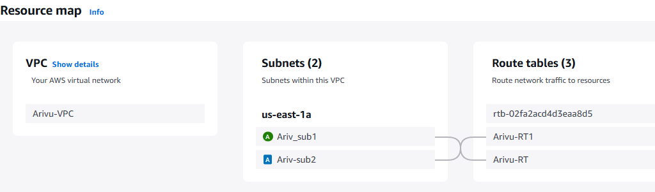

Instance Launched with VPC and Public Subnet

